Shay Walker 8-31-2018

Professor Petcaugh Web Applications-CIS 431

Research, then compare and contrast the following hosting platforms: Bluehost, GoDaddy, AWS, Azure.

Bluehost:

Bluehost offers shared hosting, cloud hosting, VPS hosting, and dedicated hosting. As far as packages for shared hosting please see the chart below.

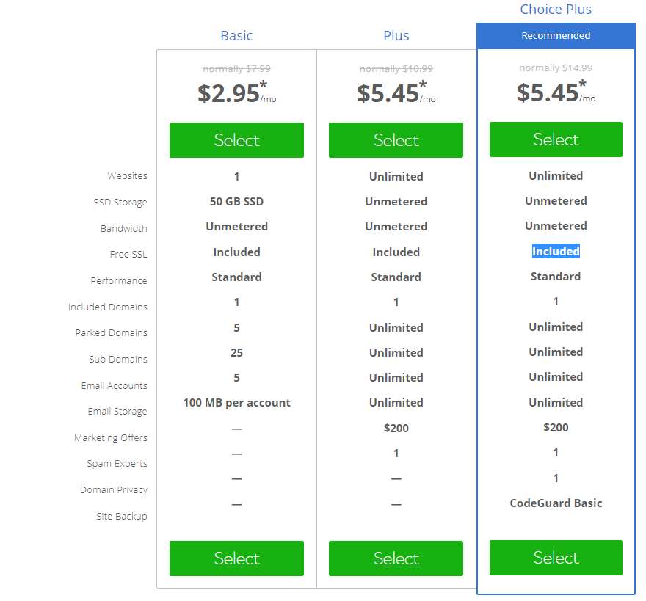

Table (Bluehost, 2018)

Cloud Hosting:

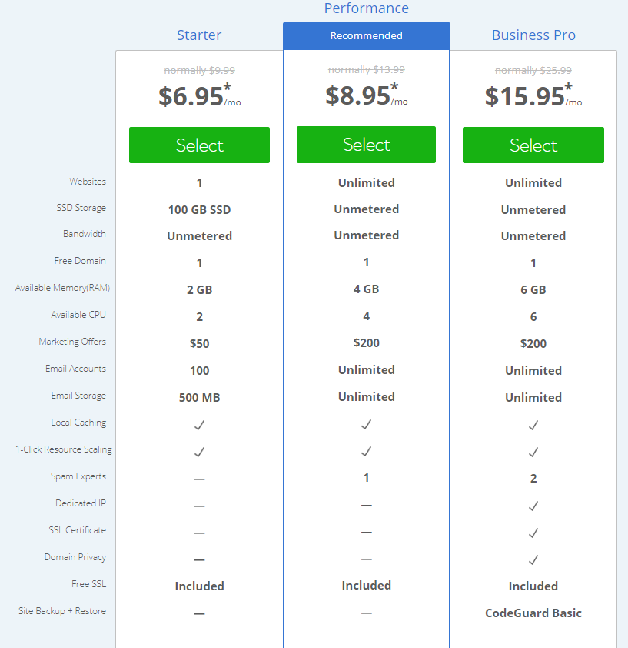

Table (Bluehost, 2018)

VPN (Virtual Private servers) Hosting:

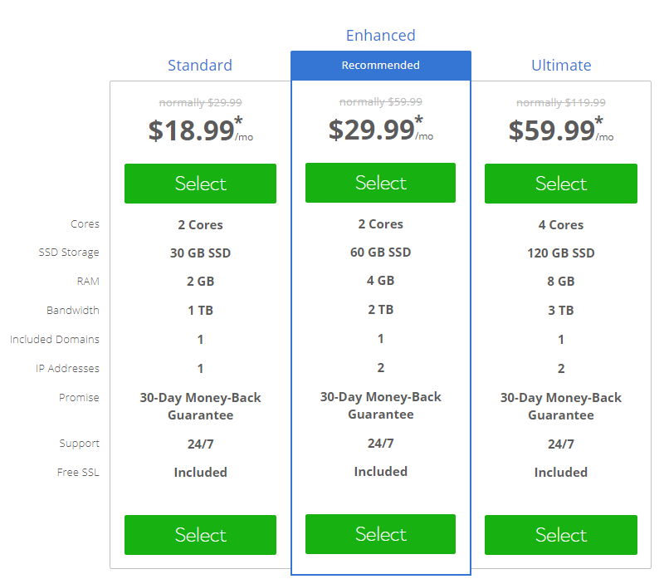

Table (Bluehost, 2018)

Dedicated Hosting:

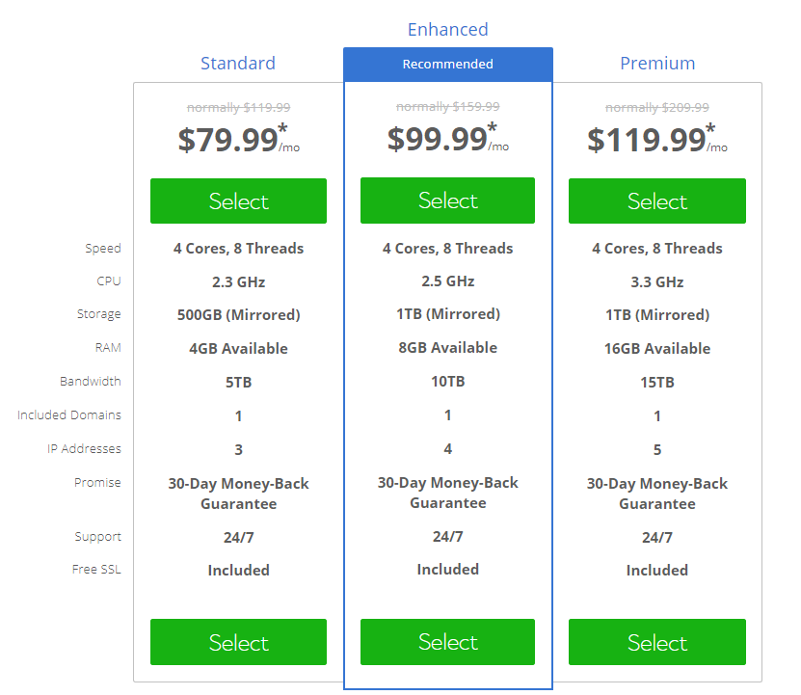

Table (Bluehost, 2018)

Summary:

Depending on what your needs are comprised of will determine which hosting package is right for the job.

GoDaddy:

GoDaddy offers web hosting, business hosting, and WordPress hosting.

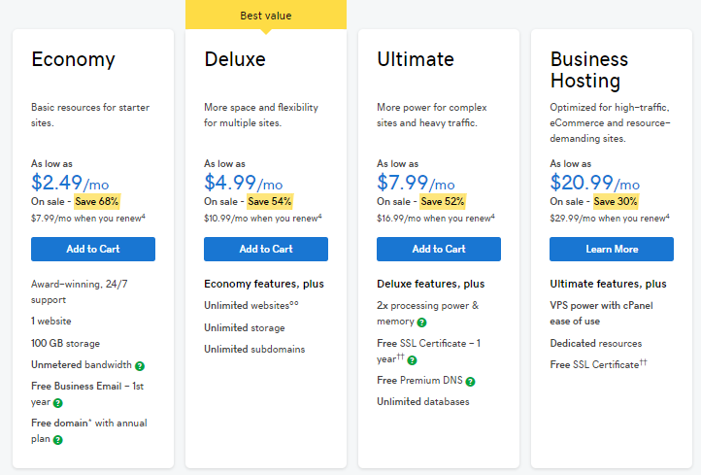

Table (GoDaddy, 2018)

Their business hosting looks to be uniquely catering to the aspects of eCommerce (fast track to more sales), high-traffic, resource heavy ( no sharing of resource like CPU or RAM).

WordPress Hosting:

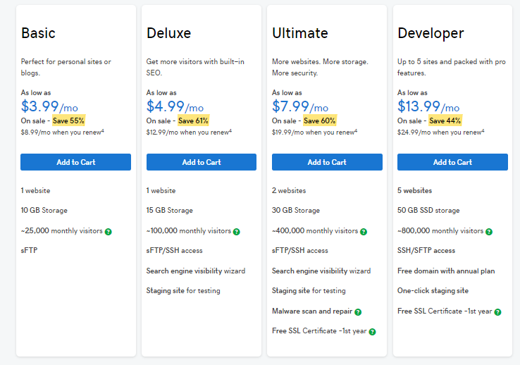

Table (GoDaddy, 2018)

Summary:

Overall there are less hosting options and plans than Bluehost. However, they cater to specific business websites very well.

AWS Hosting:

AWS Tier is free from Amazon. They appear to be catering to ease of use for new users very well. Plus, the fact that it is free is inviting.

Once 12 months are up AWS users have the choice to continue to use the features the re subscribe to on a monthly basis. They have datacenters worldwide, grow and shrink feature to deal with traffic spikes or low traffic, as well as flexible pricing where you only pay for what you use.

They offer simple, static, and enterprise web hosting.

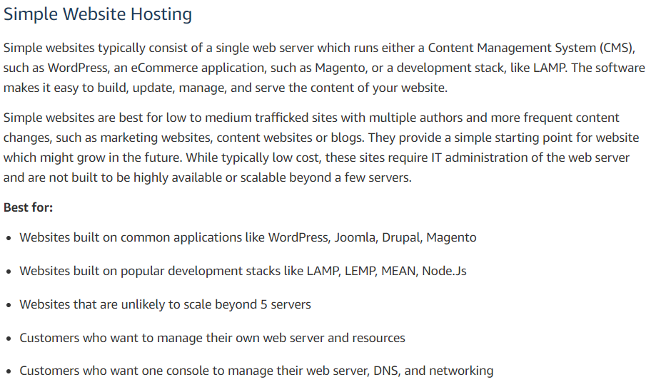

Table (AWS, 2018)

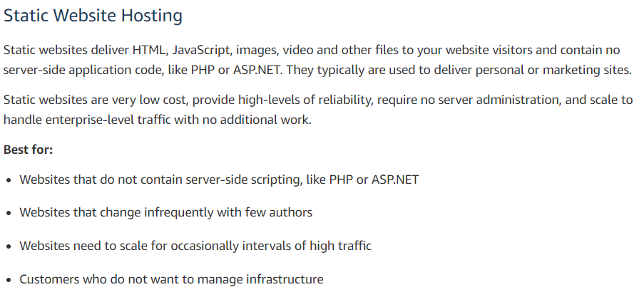

Table (AWS, 2018)

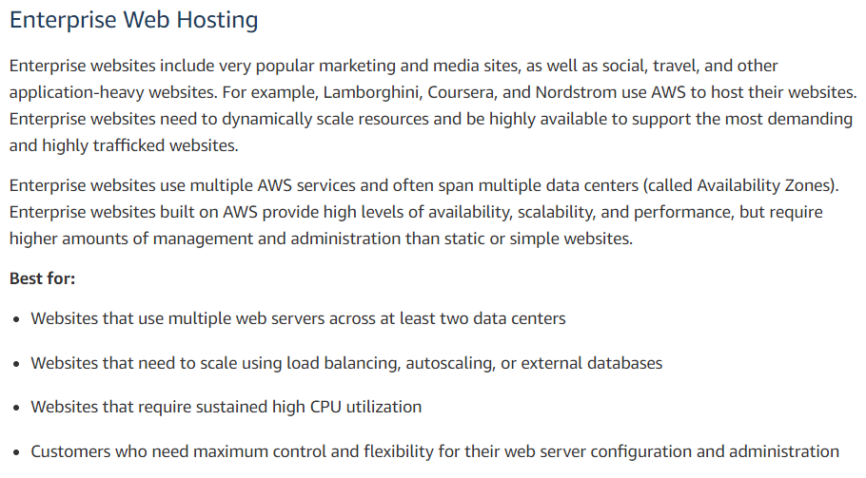

Table (AWS, 2018)

Summary:

Overall not a bad choice, however, they seem a little more baseline and simple compared to Bluehost or GoDaddy. However, the pay only for what you use was a new and interesting. AWS is also cloud based.

Azure

Azure was similar to AWS in the fact that they did the same offer with pricing and goes by only pay for what you use, and that Azure is cloud based.



Table (Azure, 2018)

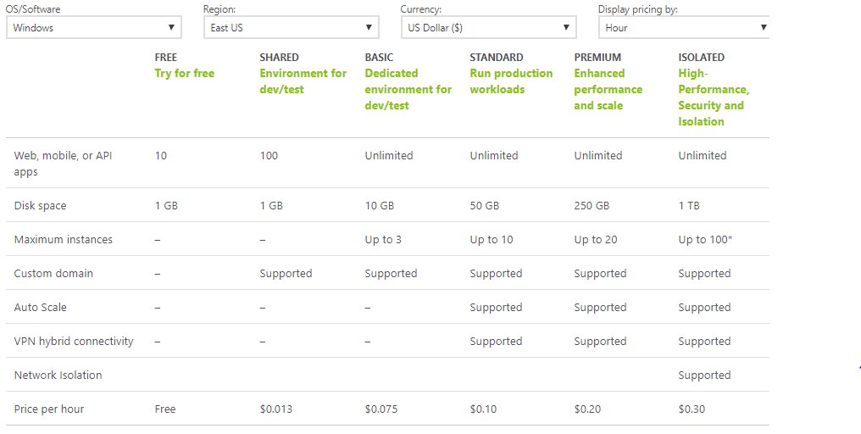

Table (Azure, 2018)

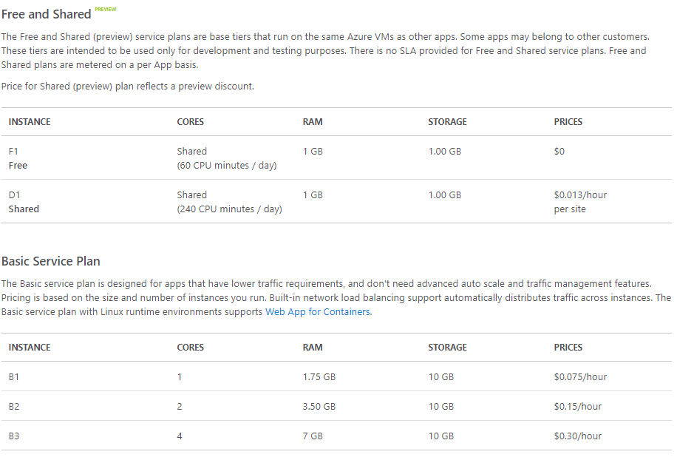

Table (Azure, 2018)

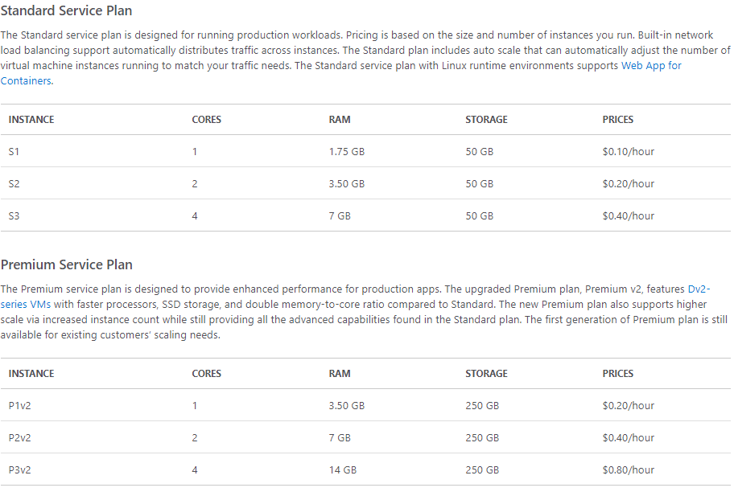

Table (Azure, 2018)

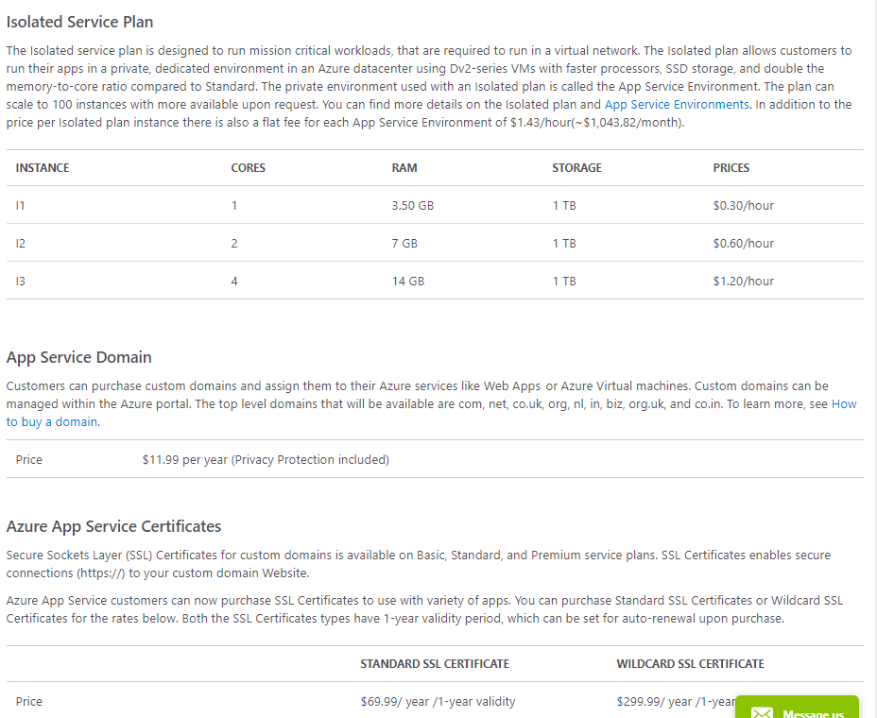

Table (Azure, 2018)

Summary:

Azure seems to be pretty solid in their features and packages. The pricing is a little hard to estimate when it is a pay per hour as you go. They also offer protection packages. They seem more substantial than AWS. They also offer a package that runs workloads in a virtual network which is pretty unique.

Work Cited

Bluehost. “Hosting Shared Hosting Cloud Hosting VPS Hosting Dedicated Hosting.” *Bluehost* , 2018, [www.bluehost.com/products/dedicated](http://www.bluehost.com/products/dedicated).

“Hosting | See Our Web Host Solutions - GoDaddy.” *Garage*, GoDaddy, 2018, [www.godaddy.com/hosting?isc=gofd2001aj](http://www.godaddy.com/hosting?isc=gofd2001aj).

“Pricing - App Service | Microsoft Azure.” *Service Level Agreements Summary | Microsoft Azure*, 2018, azure.microsoft.com/en-us/pricing/details/app-service/windows/.

“Web Hosting - Amazon Web Services (AWS).” *Amazon*, Amazon, 2018, aws.amazon.com/websites/?nc1=f_dr.